

SCHOOL OF COMPUTER SCIENCE AND ENGINEERING
MGT3015 – SUPPLY CHAIN ANALYTICS – WINTER 2025-26

PROJECT TITLE: ROUTE PLANNING AND FLEET OPTIMIZATION USING DATA ANALYTICS: A CASE STUDY OF MEGAMART E-COMMERCE HUB, CHENNAI
Date of Submission: 3/04/2026

Team Members:
M.Divya dharshini | 22MIA1048
P. SAI ESWARI | 22MIA1118
G.S. TEJASH KUMAR | 22MIA1146
S.A.Princee | 22MIA1151

ABSTRACT
The project analyzes the issue of route planning and fleet optimization at MegaMart E-Commerce Hub, Chennai, based on a logistics dataset of 2024, Tableau dashboards, and a Python forecasting strategy. The issue is the challenge of scheduling of daily truck movement with changing order quantities, variation in the demand by zones, weather interruptions, festival peaks, and the limits on modal allocation. The analysis process is a mix of descriptive dashboard analysis and predictive modelling written in Python, where the statistical and trend-based forecasting models were applied to predict the number of trucks required each day based on operational and environmental variables. The final report shows that the demand of trucks cannot be defined based on the number of orders only; the volume of parcels, weekends, festival seasons, weather, and distribution of demand within the space are all factors that can alter the fleet requirements. The model had an RMSE of 0.803 and MAPE of 0.212, which means that it has a useful forecasting accuracy in short-term planning. In general, the project demonstrates the importance of integrating business intelligence dashboards and predictive analytics in order to enhance the distribution of trucks, the discipline of their utilization, and the preparedness of operations to operate during peak hours.

INTRODUCTION :
The logistics processes of e-commerce rely on the vehicle conversion of incoming demand into effective delivery performance, and this necessity is even more problematic in the busy city area like Chennai. In the case of a warehouse-led network, the planning of routes and optimization of fleets is what will define whether customer orders are fulfilled within the necessary timeframe, whether assets are utilized efficiently, and whether operating expenses are kept at a reasonable level. Practically, the decision-making process of daily dispatch planning is affected by various interacting factors, such as the number of orders, the size of the parcels, the geographic distribution of demand, traffic conditions, vehicle capacity, and unforeseen disturbances, such as heavy rainfall.
In this background, MegaMart Logistics is portrayed as a large e-commerce business, which has its base at Ambattur Industrial estate and serves North, South, Central and West Chennai. It is an academically important project since it focuses on a practical supply chain decision issue and uses data visualization, analytical reasoning and forecasting methods to solve the problem instead of just discussing the theoretical issues. It is also highly industry relevant as urban distribution systems are now demanding data-driven decision making to keep service levels steady under highly fluctuating demand conditions.
The research combines the dashboard analysis using Tableau with the quantitative forecasting models to gain a better insight into the demand trends and enhance the fleet planning decision-making. Through the integration of both descriptive and predictive thinking, the project will help to improve the efficiency of trucks allocation, utilize more efficiently, and remain operational during the periods of peak demand like weekends, festivals, and bad weather.

PROBLEM STATEMENT:
The project solves the logistics planning issue characterized by the variability of demand, inefficient use of the fleet, and complexity in route planning. The order volume varies significantly daily throughout the year, whereas the ratio of bike-deliverable and truck-deliverable orders imposes varying demands on transport capacity. Meanwhile, zone-level imbalance, weather-related delays, and festival-related surges introduce uncertainty in operations that make it challenging to plan dispatch and expose SLAs and expensive last-minute rentals.
Another difficulty is the gap between the nominal vehicle availability and the effective vehicle productivity. Poor cube usage, poor route loading, and congestion sensitive delivery routes can also decrease efficiency in the case of trucks even with trucks available. The project does not only explore the number of trucks necessary, but also how the allocation decisions of the fleet can be better made by understanding the analytical insight.

OBJECTIVE:
• Predict the daily truck demand based on the provided operational data and a finalized predictive model.
• Optimize fleet distribution in the four delivery areas in accordance with the measured demand changes and route parameters.
• Enhance delivery efficiency by enhancing the utilization, modal shift and peak-day demand trends.
• Cut logistics cost and SLA infractions by informing the planning of owned and rented fleet capacity better.

DATASET DESCRIPTION :
The dataset to be used in the project is the Excel dataset named chennai_ecommerce_truckload_2024_Forecasting-Truck-load.xlsx, comprising of one year of daily logistics data in 2024. The data has 366 observations per day and 23 variables, both demand-side and transport-side variables that apply to fleet planning. This width renders the dataset suitable to exploratory analytics, scenario analysis, and truck-demand forecasting.
The main variables are the total orders, zone-wise orders (North, South, Central, West), average item characteristics, average parcel weight, average volume per order, rain event, rain intensity, bikes required, truck required, bikes required, and average route distance. Derived volume measures of truck and bike allocation are also included in the dataset, which will enable the project to evaluate the cube utilization and mode split at the operational level. Consequently, the data allows a multivariate interpretation of transport demand as opposed to the volume-only approach.

VISUALIZATION :
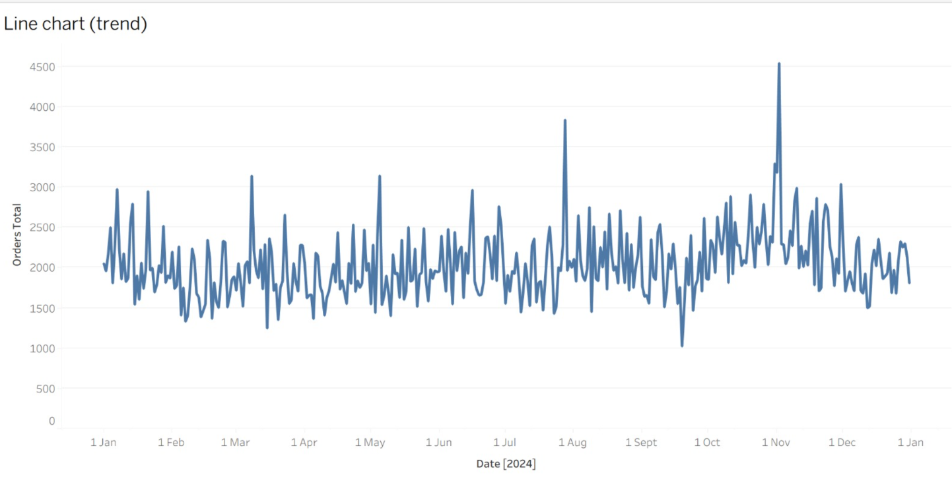
Figure1:
Line Chart (Trend):The daily order time series reveals high volatility over the year 2024 with noticeable spikes in the second part of the year, which is during the festival season. Normal days have a range of 1,500-3,000 orders as the baseline and above 4,000 orders as the peak due to the festival. Such variability renders the process of planning a fleet in advance unreliable and makes it necessary to have dynamic truck allocation based on data.
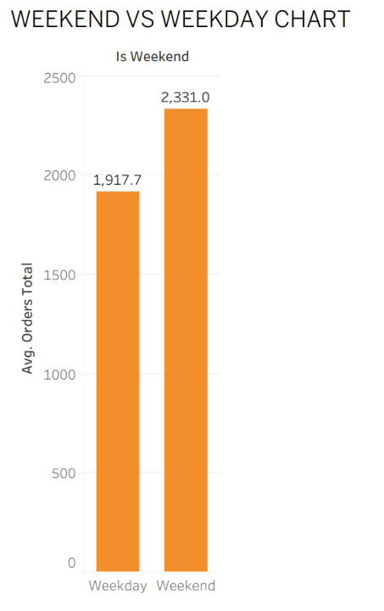
Figure 2:
Weekend vs. Weekday Chart:Weekend operations result in significantly greater demand, whereby the average order of 2,331.0 is achieved on weekends, versus 1,917.7 on weekdays, which is a difference of 21.6. This would mean increased truck demands on weekend and that capacity buffers are to be planned systematically on the weekend of Saturday and Sunday.

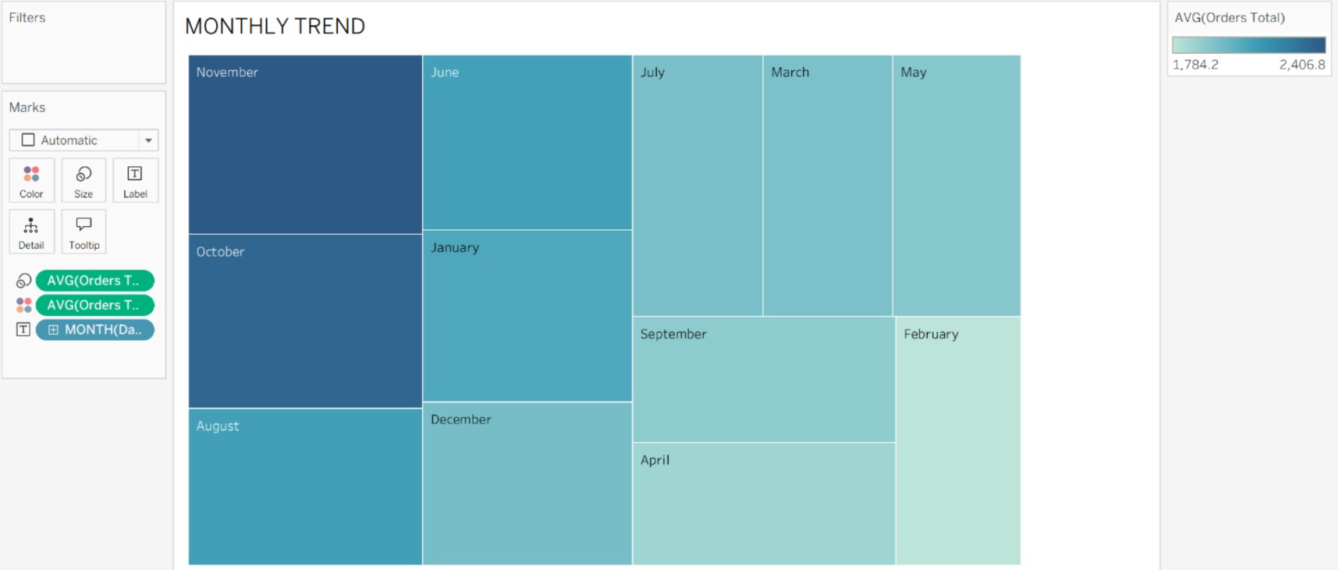
Figure3:
Monthly Trend: Treemap visualization indicates that the months with the highest volume are November, August, and October, and the lows of the seasons are February and March. This seasonal trend offers some foundation to proactive capacity planning whereby fleet growth is required over the October-December period.
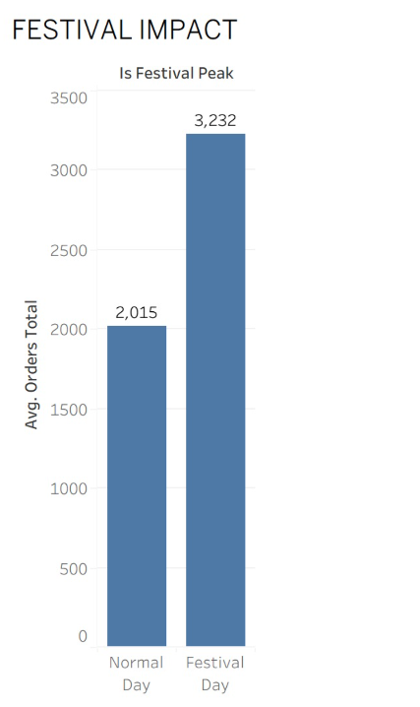
Figure4:
Festival Impact:Festive-peak days have 3,232 more orders than normal days- 2,015 on average- an increase of about 60.4. Such dramatic uplift supports the necessity of pre-planned rental agreements and stand-by fleet allocation in the specific festival windows as Diwali, Pongal, and Christmas.
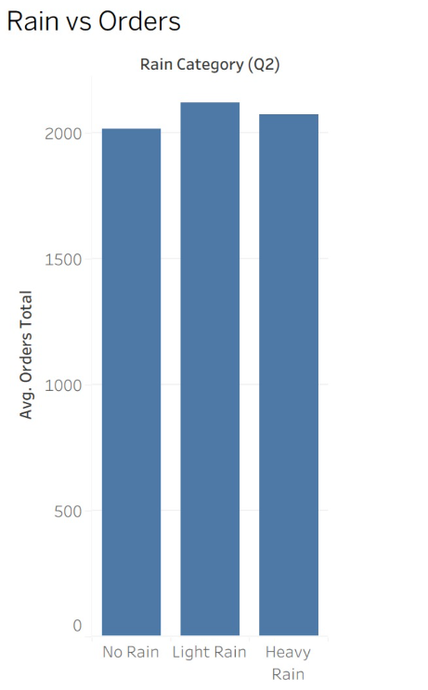
Figure 6:
Rain vs. Orders: The median number of orders of No Rain (~2,000), Light Rain (~2,125), and Heavy Rain (~2,075) are not very far apart, which means that rainfall is not a demand suppressor. The customers keep on making orders even when there is a rain event and this implies that there is no decrease in operational pressure during unfavourable weather conditions, on the contrary, it tends to increase.
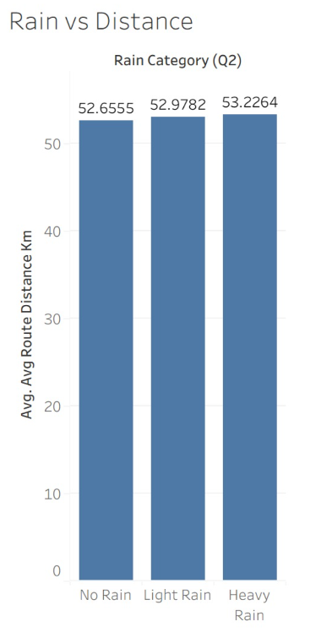
Figure 7:
Rain vs. Distance: Route distances are relatively constant with rain types (all within a range of 45 km). This indicates that rain has no significant impact on routing decisions over the short-term; nevertheless, it probably causes a higher travel time and decreased per-truck delivery throughput because of traffic jams and slower movement.
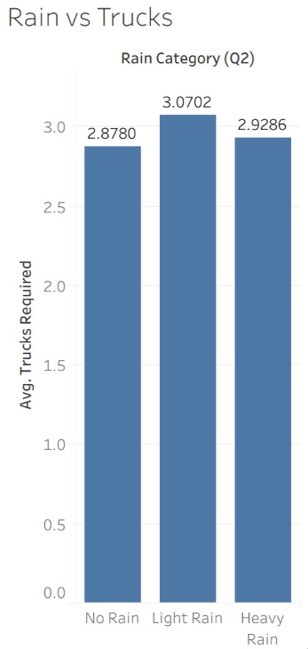
Figure 8:
Rain vs. Trucks: The situation with heavy rain is that the trucks demand is slightly higher (~3.0 trucks) as opposed to No Rain (~2.9 trucks) and Light Rain (~3.05 trucks). Although the differences are small in terms of averages, the heavy-rain category is characterized by high tail risk. According to the assumption about the project brief of 20% productivity loss during intense rain (more than 50 mm), the suggested truck demand on these days is no longer 2.93 but rather about 3.93 trucks - a considerable operational buffer requirement.
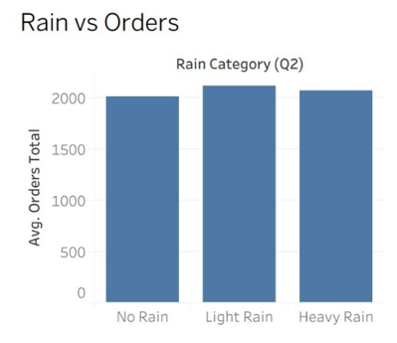
Figure 9:
Rain vs. Orders: The means of the counts of orders in the categories of No Rain (mean=2,000), Light Rain (2,125), and Heavy Rain (2,075) are not too far apart, which means that rain alone does not hold the demand down. The fact that customers keep on placing order even during rain events implies that there is no decrease in operational pressure even during poor weather conditions but usually, the pressure is heightened.
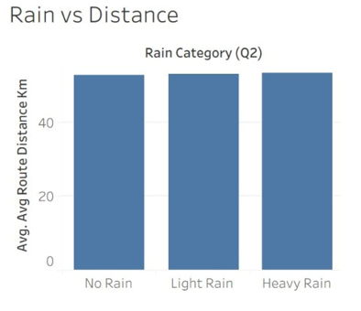
Figure 10:
Rain vs. Distance: The distance of routes does not change significantly with the type of rain (all mean 45 km). This is an indication that rain has no significant effect on routing decisions in the short-run, but it is probable that it raises the travel time and per-truck delivery throughput as a result of traffic congestion and reduced navigational speed.
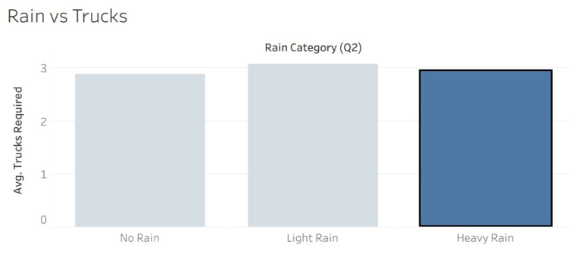
Figure 11:
Rain vs. Trucks: The rainy weather is correlated with a somewhat bigger truck demand (~3.0 trucks) than No Rain (~2.9 trucks) and Light Rain (~3.05 trucks). Although the variations are small on average, the heavy-rain group exhibits high tail risk. Following the project brief assumption of a 20 percent productivity loss during severe rain (> 50 mm), the implied truck requirement on these days increases too, as indicated by the project brief of approximately 2.93 trucks to about 3.93 trucks - a sizeable operational buffer requirement.
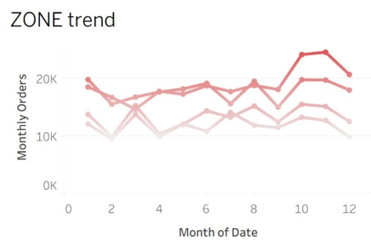
Figure 12:
Zone Trend: The multi-line chart indicates that the four zones have the same seasonal trend over the year, with a high in Q4. North and South zones constantly register greater volume of orders every month (18,00025,000) than Central and West zones, which level off at 10,00015,000. The fact that this gap has persisted shows that there is a structural and not seasonal demand hierarchy.
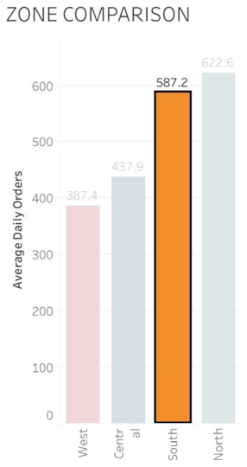
Figure 13:
Zone Comparison: North zone has the highest total number of orders per day (622.6) and then South (587.2), Central (437.9) and West (387.4). Allocating equal amounts of trucks to the four zones would be operationally inefficient because North, the most demanded zone on average would produce 61 percent more demand than West. The first-wave truck loading and dock sequencing should be arranged in such a way that it focuses on the North and South corridors.
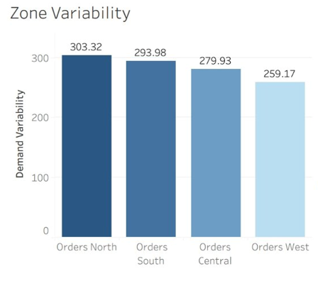
Figure 14:
Zone Variability: North has the greatest demand variability (standard deviation of 303.32), South (293.98), Central (279.93) and West (259.17). The greater fluctuation on the dominant zone implies that North is not only the most difficult to serve but also to plan. North should focus on SLA risk through reserve capacity and nearer short-term forecasting.
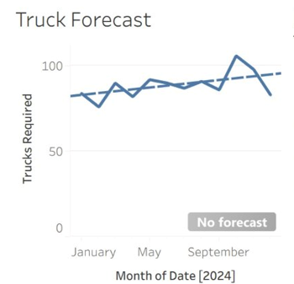
Figure 15:
Truck Forecast: The monthly truck need graph has an undulating yet an overall increase in trend, with significant peaks in October- November that coincide with the season peak of the festival. The trendline shows us that the fleet demand does not remain the same, it increases at a modest rate throughout the year, which makes the argument of planning to rent in advance more than sufficient to do so way before the peak seasons.
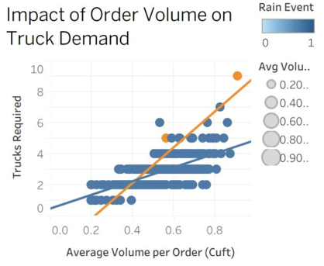
Figure 16:
Effects of Order Volume on Truck Demand: This scatter plot shows that the average volume per order (in cubic feet) and required trucks have a strong positive correlation. The slope of the orange trend line is steeper than the slope of the blue line, which indicates that the volume to truck relationship is compounded by rain events. Average volume per order is correlated with required trucks 0.663 - the best predictor in the data set. This proves that order count is not a major determinant of capacity pressure but rather shipment bulkiness.
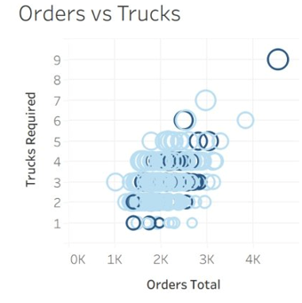
Figure 17:
Orders vs. Trucks (Bubble Chart): The bubble chart confirms that there is moderate positive relationship between total daily orders and trucks required (correlation = 0.500), but there is high scatter. The darker bubbles (greater probability of a rain event) will be more concentrated at a greater number of trucks per order volume, which validates weather as a confounding factor. Multivariate forecasting is justified by this dispersion as compared to simple linear estimation.
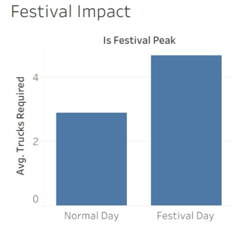
Figure 18:
Festival Effect on Truck Demand: Festival-peak days have an average of about 4.67 trucks as compared to normal days of about 3.0 trucks an increase of about 55. This quantitative gap goes directly into the Diwali scenario analysis where a 25 percentage point increase in demand would push the estimated truck requirement to around 5.83 trucks per day.
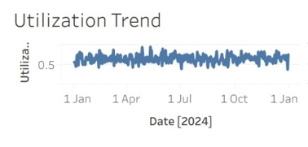
Figure 19:

Utilization Trend: The utilization KPI of 0.6554 (65.54) shows that the average loading of trucks is to 380 cu.ft capacity, which means that on average the trucks are loaded to two-thirds of their load capacity. Although this is operationally stable, it indicates that on an average 34 percent of truck capacity is underutilized on a trip basis. The ability to consolidate routes, build loads, and standardize the packages would help to improve this measure and lower the cost of the fleet and the number of vehicles rented.
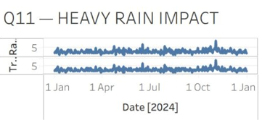
Figure 20:
Heavy Rain Impact: The two time-series validates the fact that heavy rain events (upper line) stimulate increased truck requirements than the base periods and this is not a phenomenon limited to a specific season but is observed throughout the year. The most obvious deviation is observed during the monsoon months, which confirms the necessity of weather-dependent fleet guidelines.
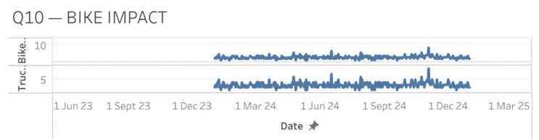
Figure 21:
Bike Impact: In a rolling view, the bike-eligible orders per day (numbering around 8-9) and the truck-assigned orders per day (numbering around 5) have a long-term trend of repeated behavior of the bike-delivery time series (since mid-2023). This panel is a confirmation that there is significant share of daily orders that are structurally biking eligible. In the 15% bike-shift condition, the daily truck demand is reduced to around 2.23 trucks on average, which is a physical decrease that justifies modal expansion as a fleet optimization tool.
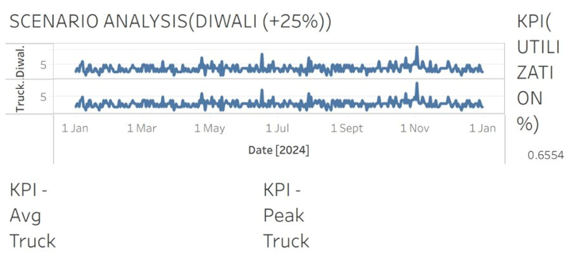
Figure 22:
Scenario Analysis Diwali (+25%): The Diwali uplift scenario indicates that the use of a 25% increase in the demand on the festival-day truck baselines produces an average of 5.83 trucks per day. The two-band display of the dashboard indicates the difference between base and scenario truck requirements throughout the year. Together with the KPI summary panel that displays average and maximum truck indicators, this display gives the management a direct decision-support framing of pre-festival capacity reservation.
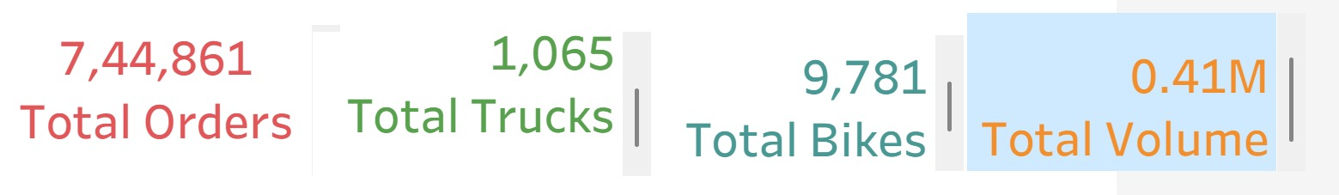
Figure 23:
The system handles a high demand of around 7.45 lakh orders, averaging over 2,000 orders daily, indicating a large-scale operation where inefficiencies can cause major losses. With only 1,065 trucks, they are a limited and critical resource, requiring efficient allocation to manage the workload. The presence of 9,781 bikes shows strong reliance on last-mile delivery, ensuring faster and cost-effective operations in urban areas. However, with a total volume of 0.41M cu.ft, truck utilization is only about 60–70%, indicating underutilization and opportunities for better optimization.

KEY INSIGHTS
- One, the weekend demand is superior in structure compared to the weekday demand, with the average orders growing by approximately 1,917.7 to 2,331.0 (a 21.6% improvement) and the average truck requirement growing by 2.81 to 3.17 trucks. Weekend uses are to be considered as scheduled peak uses that have special capacity buffers.
- The largest order surge is during festival periods where average orders increase to about 3,231.5 during festival days and 2,015.2 during non-festival days which is a 60.4% increase. This brings out festivals as the most crucial trigger of proactive planning of rental and dispatch expansion.
- The geographical distribution of demand is skewed with North and South making the greatest average number of daily orders (622.6 and 587.2 orders on average). Even distribution of the trucks among the zones would be operationally inefficient and strategically off-track.
- North is the most volatile zone, as well as the highest-demand with a standard deviation of 303.32. This indicates the necessity of the reserve capacity and stricter short-term forecasting monitoring in that area.
- The Parcel volume is more correlated with truck requirement than with simple order count with the correlation standing at 0.663. Capacity pressure is significantly caused by shipment bulkiness.
- The correlation between the total orders and the number of trucks that are needed is positive but the strength of the relationship is moderately strong (correlation = 0.500) which proves that the truck planning is not determined by the demand measure alone but by a combination of variables.
- Rain operations have a moderate impact, except when severe-rain productivity assumptions are used. Weather contingency rules that are based on thresholds are more suitable in comparison with the overreaction based on the rain.
- The average utilization of cubes is 65.5, which means that there is a significant potential to enhance the efficiency of its operations by ensuring that it has a better load planning and route consolidation.

RECOMMENDATION:
- MegaMart should continue to have a mixed ownership model whereby the regular demand is taken by owned trucks, and festival, weekend, and severe-rain surges are taken by rented trucks. The daily truck demand is 2.91 with a peak of 9 trucks hence full ownership of the fleet will not be economical.
- The firm needs to consider the expansion of mid-sized EV cargo vehicles and bike-based urban deliveries to dense short-haul routes since modal shift will decrease truck-reliance and enhance flexibility in congested routes.
- The use of dynamic fleet allocation as opposed to fixed zone assignment is desirable since the level of demand and variability in North (622.6), South (587.2), Central (437.9), and West (387.4) Chennai zones vary significantly.
- The performance of delivery in high traffic regions like OMR, T Nagar and Porur is to be enhanced with the help of prior dispatch waves, geographic clustering, stricter route sequencing, and more rigid cutoff management.
- Load-building rules, route consolidation, and packaging standardization should be better used to help optimize cube utilization. The present utilization rate of 65.5% is a huge ratio of operational efficiency.
- There should be a real-time weather monitoring protocol that will allow the dispatch team to mobilize standby truck capacity to be used whenever there is a rainfall prediction that is above the 50 mm mark that was identified in the project brief.

CONCLUSION:
The final project provides a consistent and practically applicable analytics framework of route planning as well as fleet optimization of MegaMart E-Commerce Hub, Chennai. The presented evidence shows that the dynamics between the weekly demand cycle, demand cycle surges at the festival, parcel volume, weather and demand distribution at the zone level influences the demand of trucks. The combination of dashboard-based interpretation and forecasting methods is helpfully applicable to managerial value, as it is used to make action-oriented decisions of truck allocation in advance and not reactive dispatching.
The most significant input of the project to academic life is the applied business interpretation of logistics data. The paper shows that the efficiency of logistics in urban e-commerce is not only how well the demand is forecasted but also how the insight on demand can be transformed into fleet design, improvement of utilization, and contingency planning. The project therefore offers a good basis on strategic and tactical decision making in the actual distribution environment.

